THIẾT KẾ KỸ THUẬT HỘP KÍN ĐẶT VÀ RÚT NKW CHO BN COVID-19

Design of CLOSED arcrylic box for intubation and extubation for COVID-19 patients
Vietnames Society of Anesthesiologists (VSA)

(Clip for intubation using the box and its instructions for use document (Vietnames only) are also availabe at VSA website or its FB at https://www.facebook.com/vnanesth.org/?ref=br_rs)

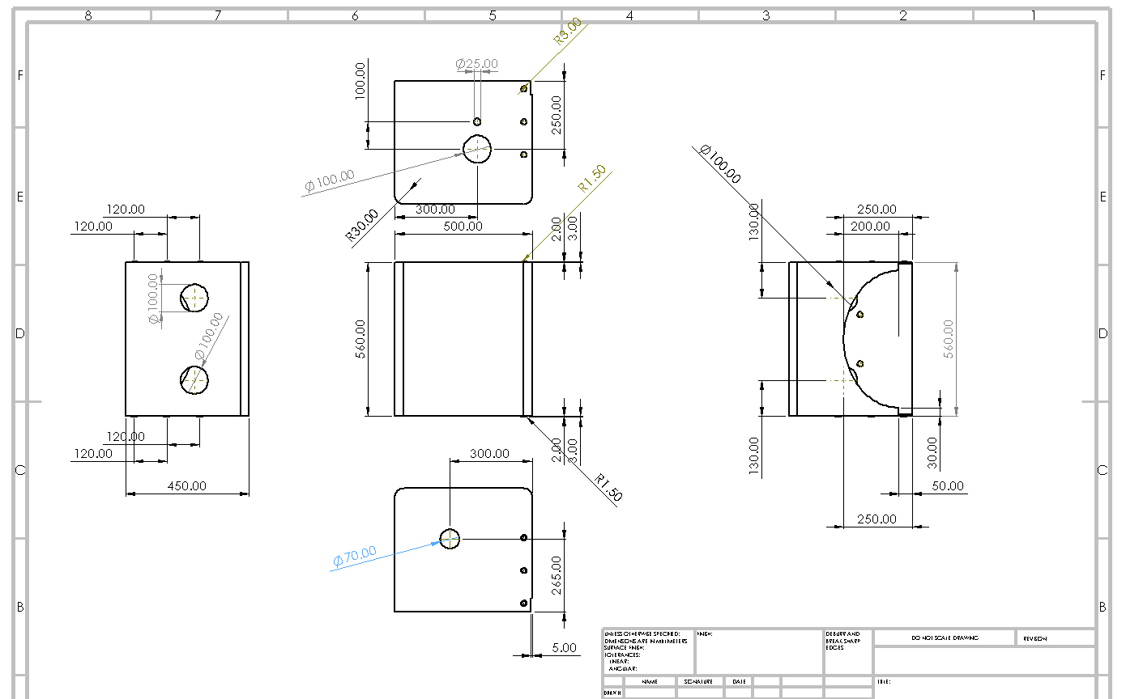

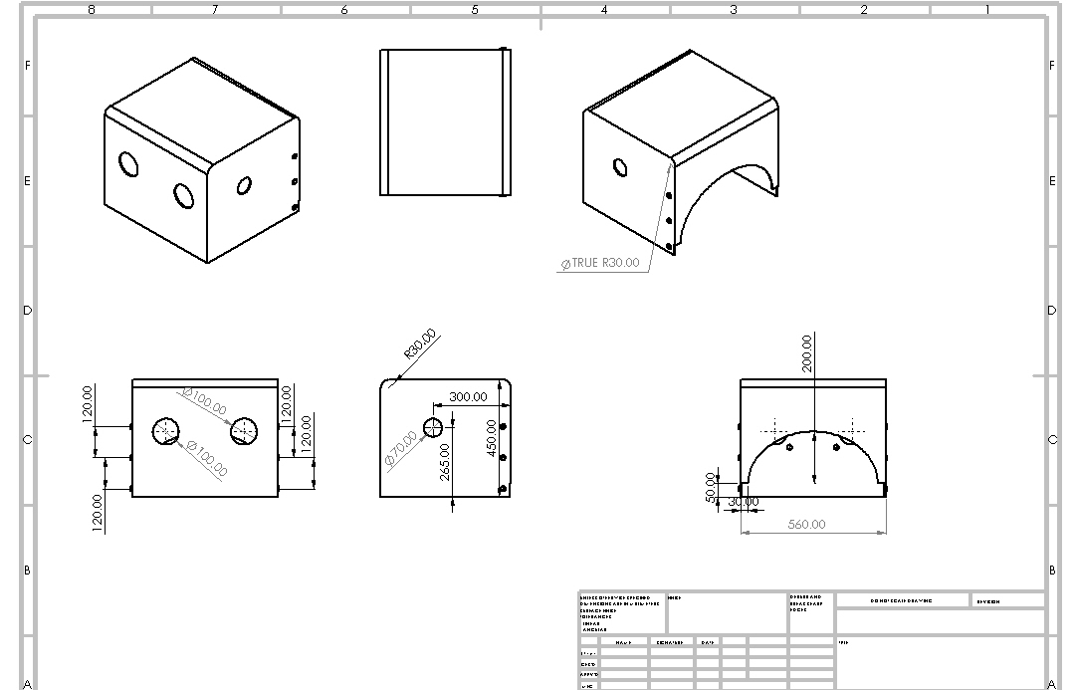

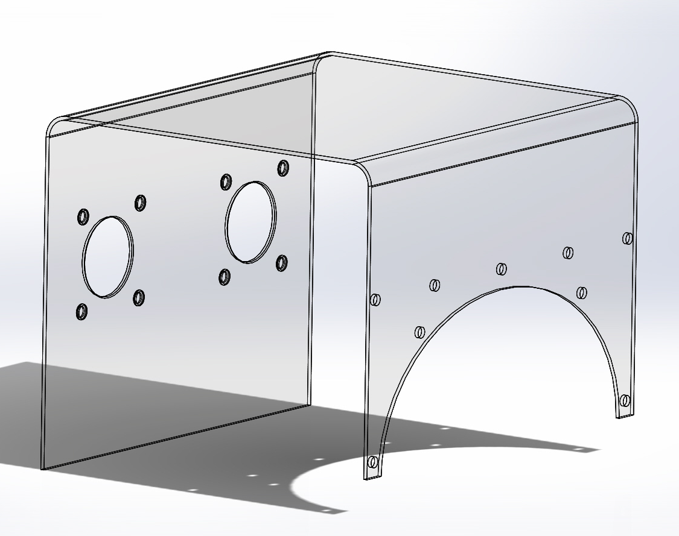Transparent arcrylic plate 1350x560 mm bended as U shape | 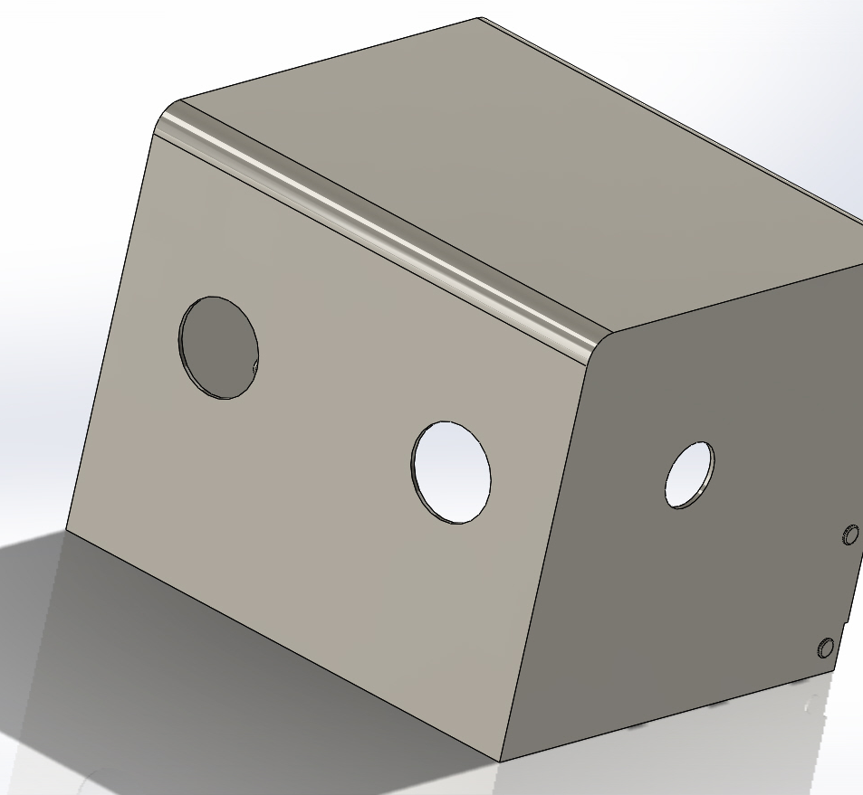  Front holes 100mm for intubator’s hands  Rightside hole 70mm for breathing circuit (filter is in side the box)
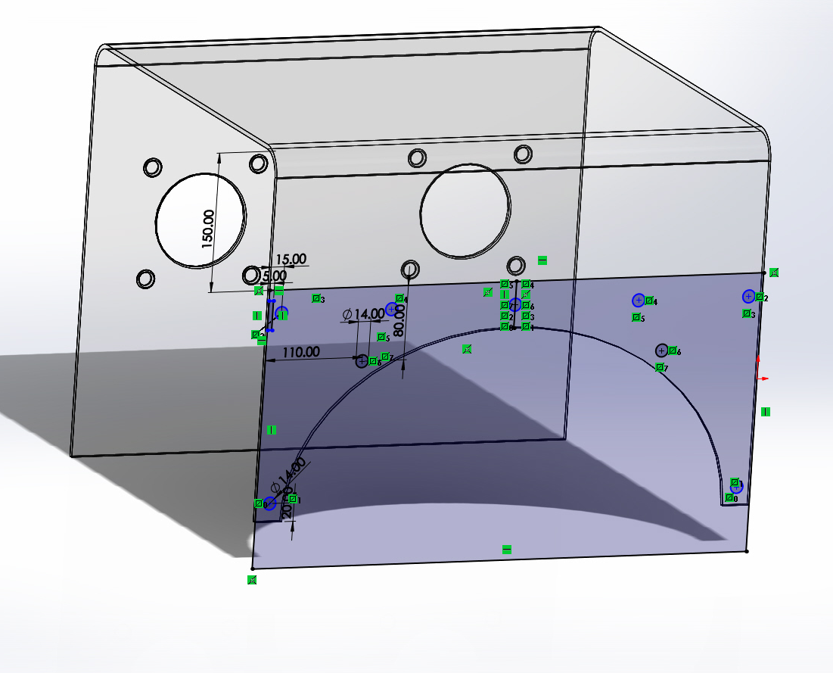  “Peg-button” postions for to hold PVC covering leg-end of the box | 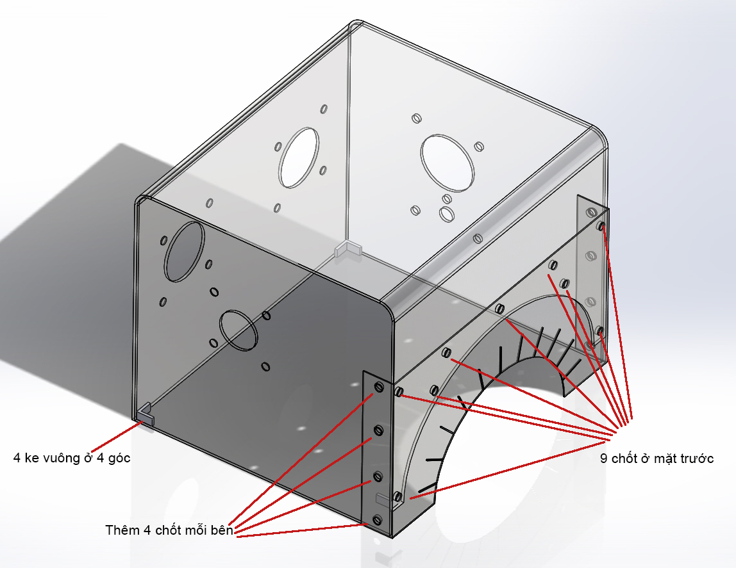  Transparent PVC 1,5mm thickness to close the box at the leg-end
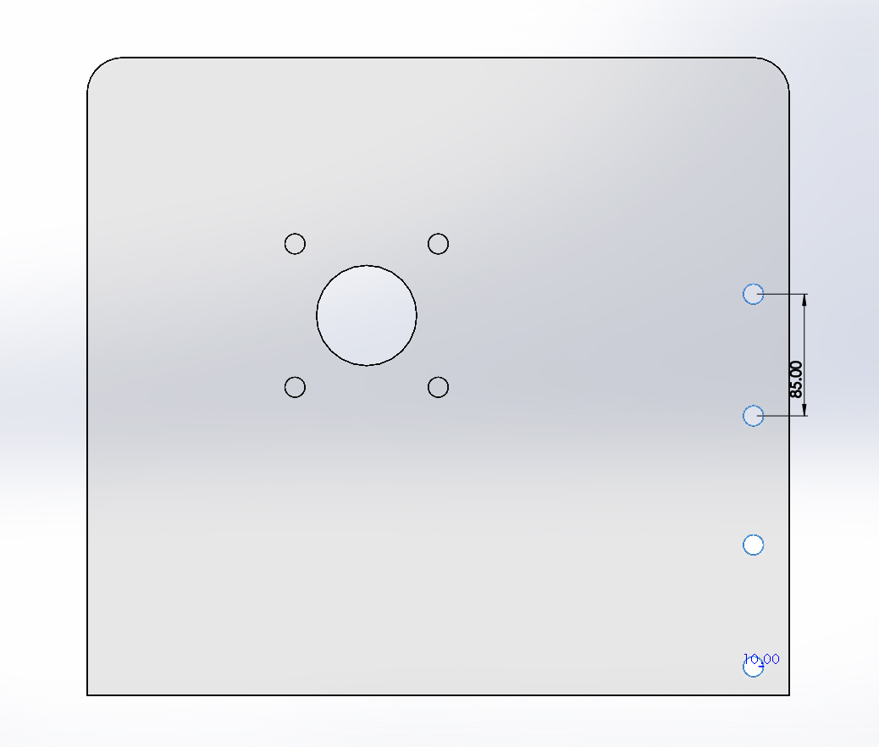  Right side hole 70mm for breathing circuit (filter is in side the box) | 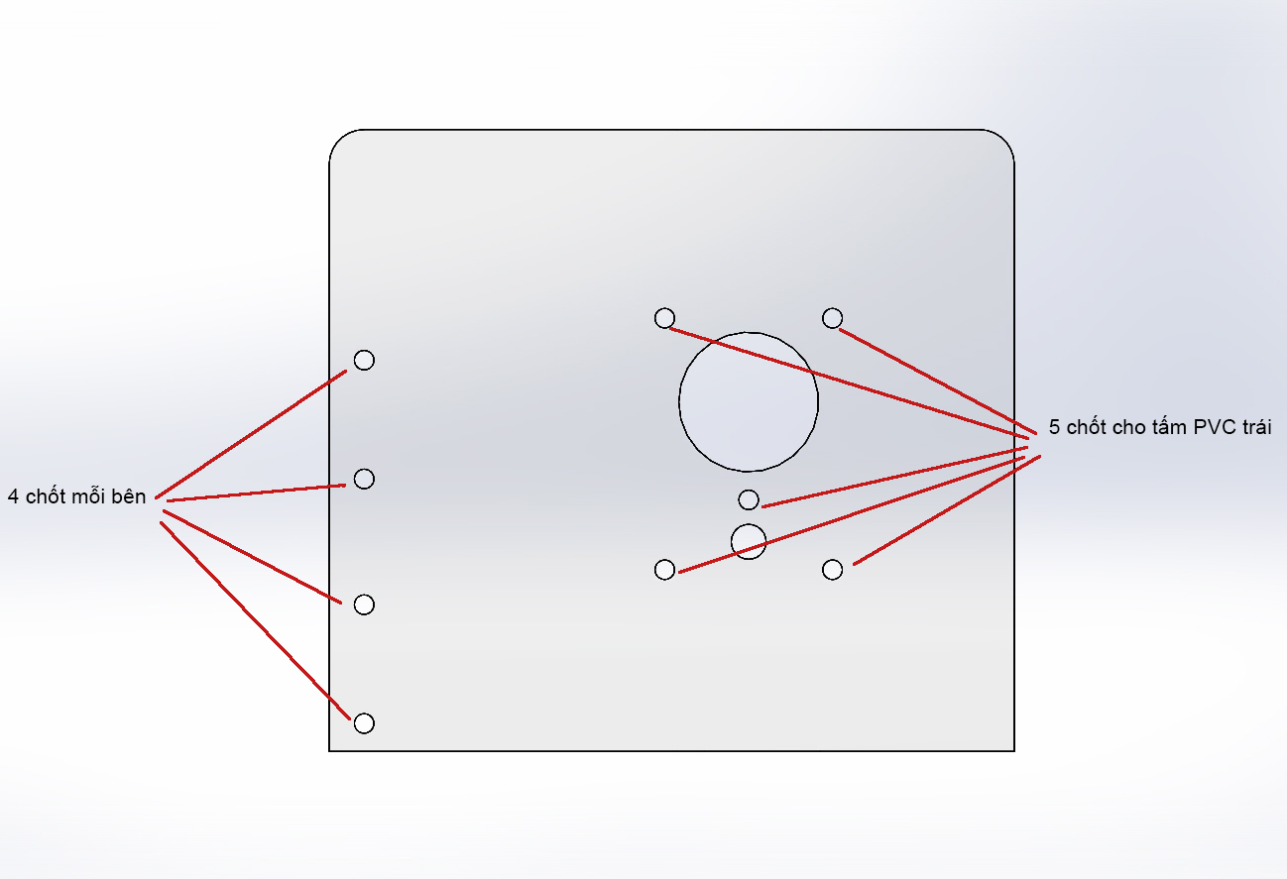  - “Peg-button” position  - Big hole 100mm: For assistant hand  - Small hole 25mm: For continue suction tubular.
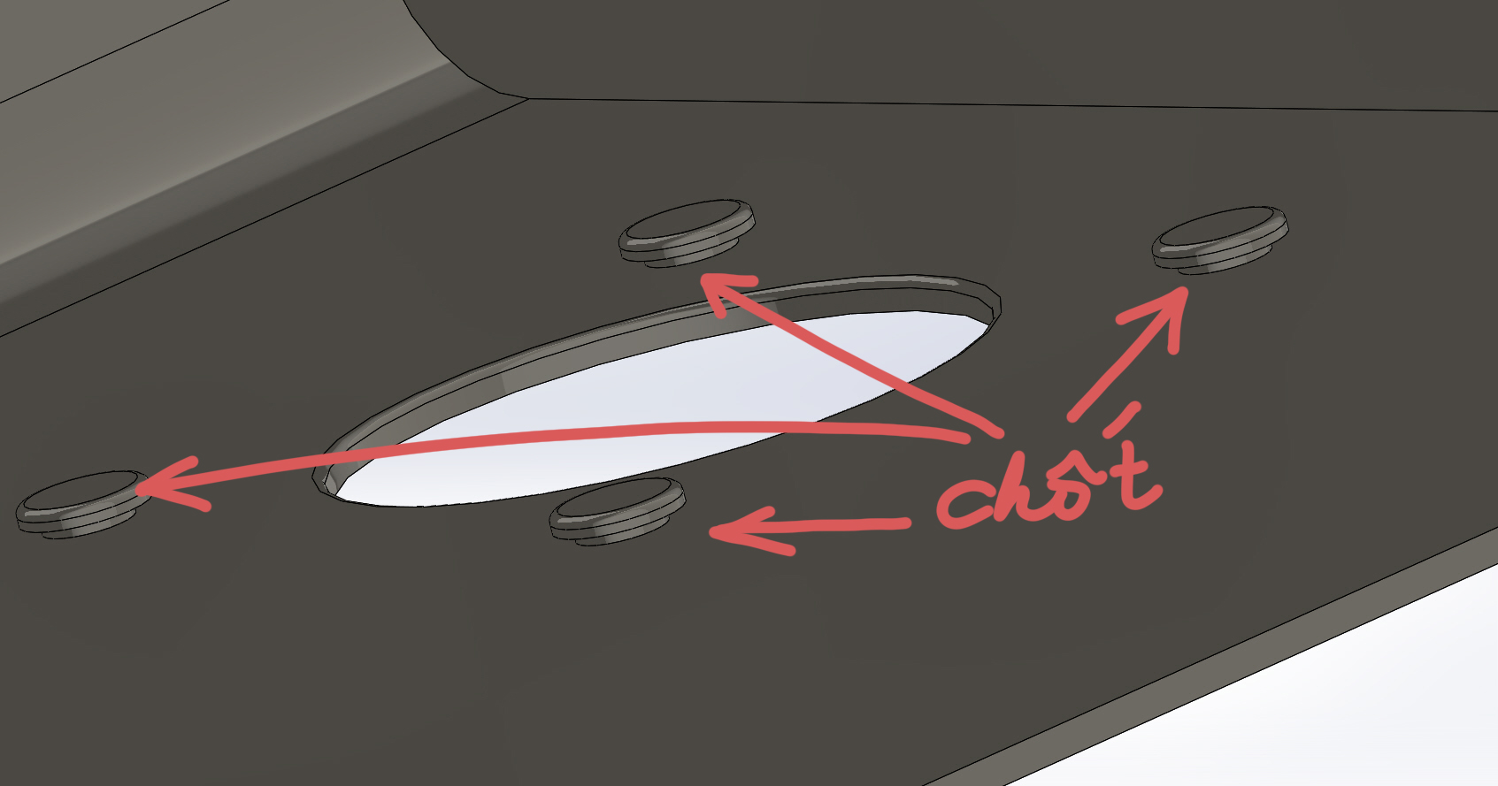  Transparent arcrylic “Peg-button” to hold PVC pice | 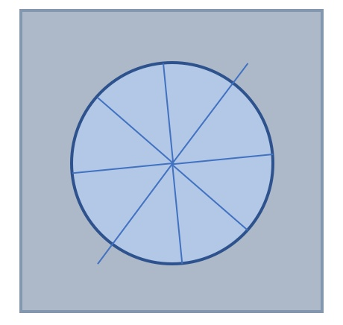  Transparent PVC 1,5mm thickness to close all the holes
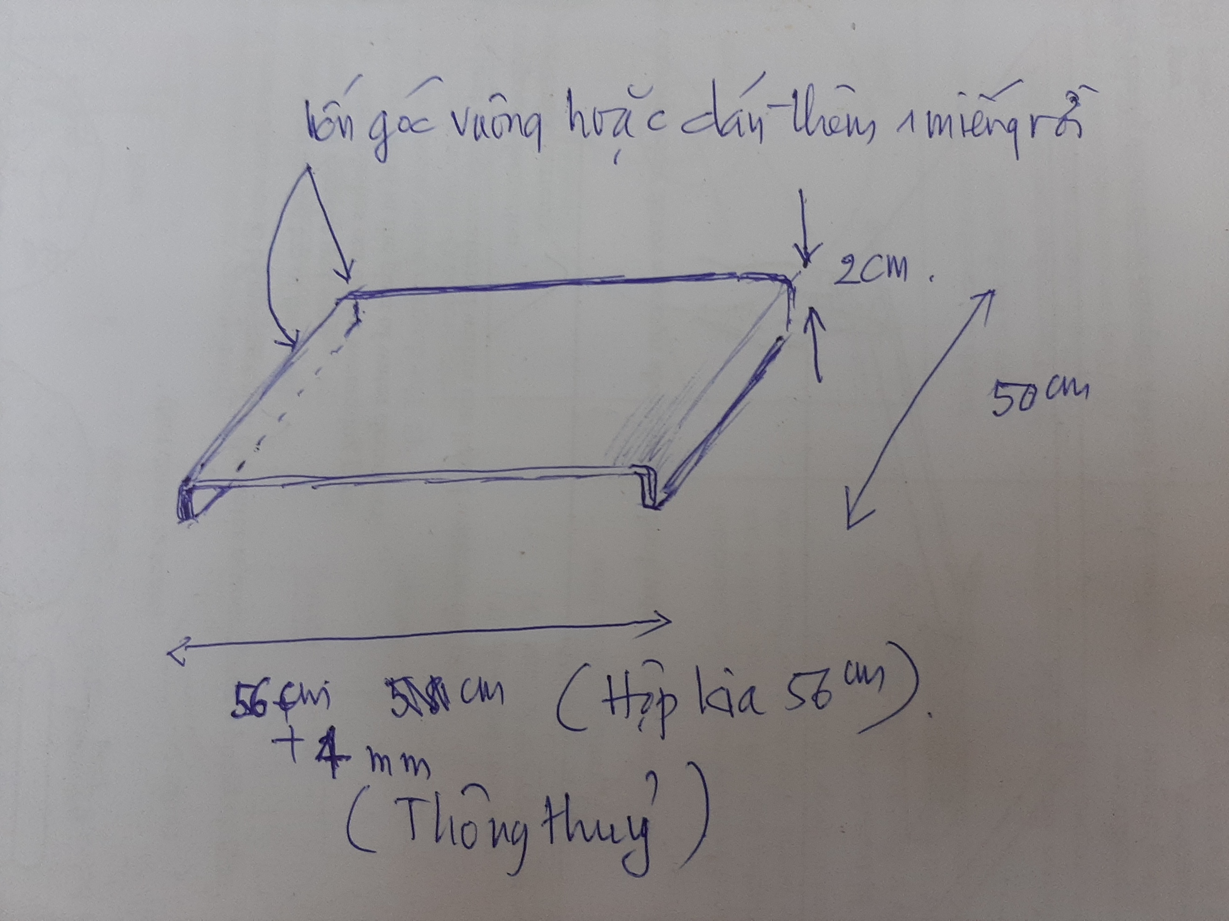 | Separated acrylic 604x500mm plate bended as U shape. Intubation for patients on operating table will need it (no need for ICU patients)

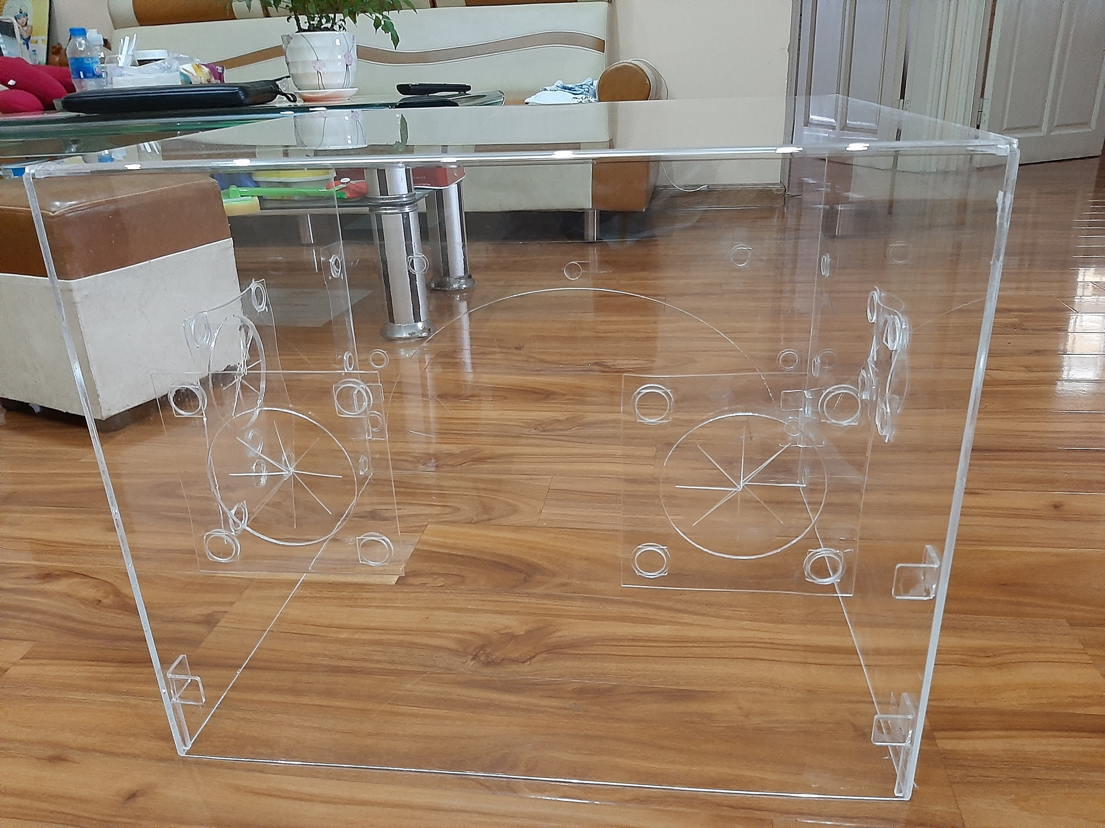  A real box photo: Head-end of the box | 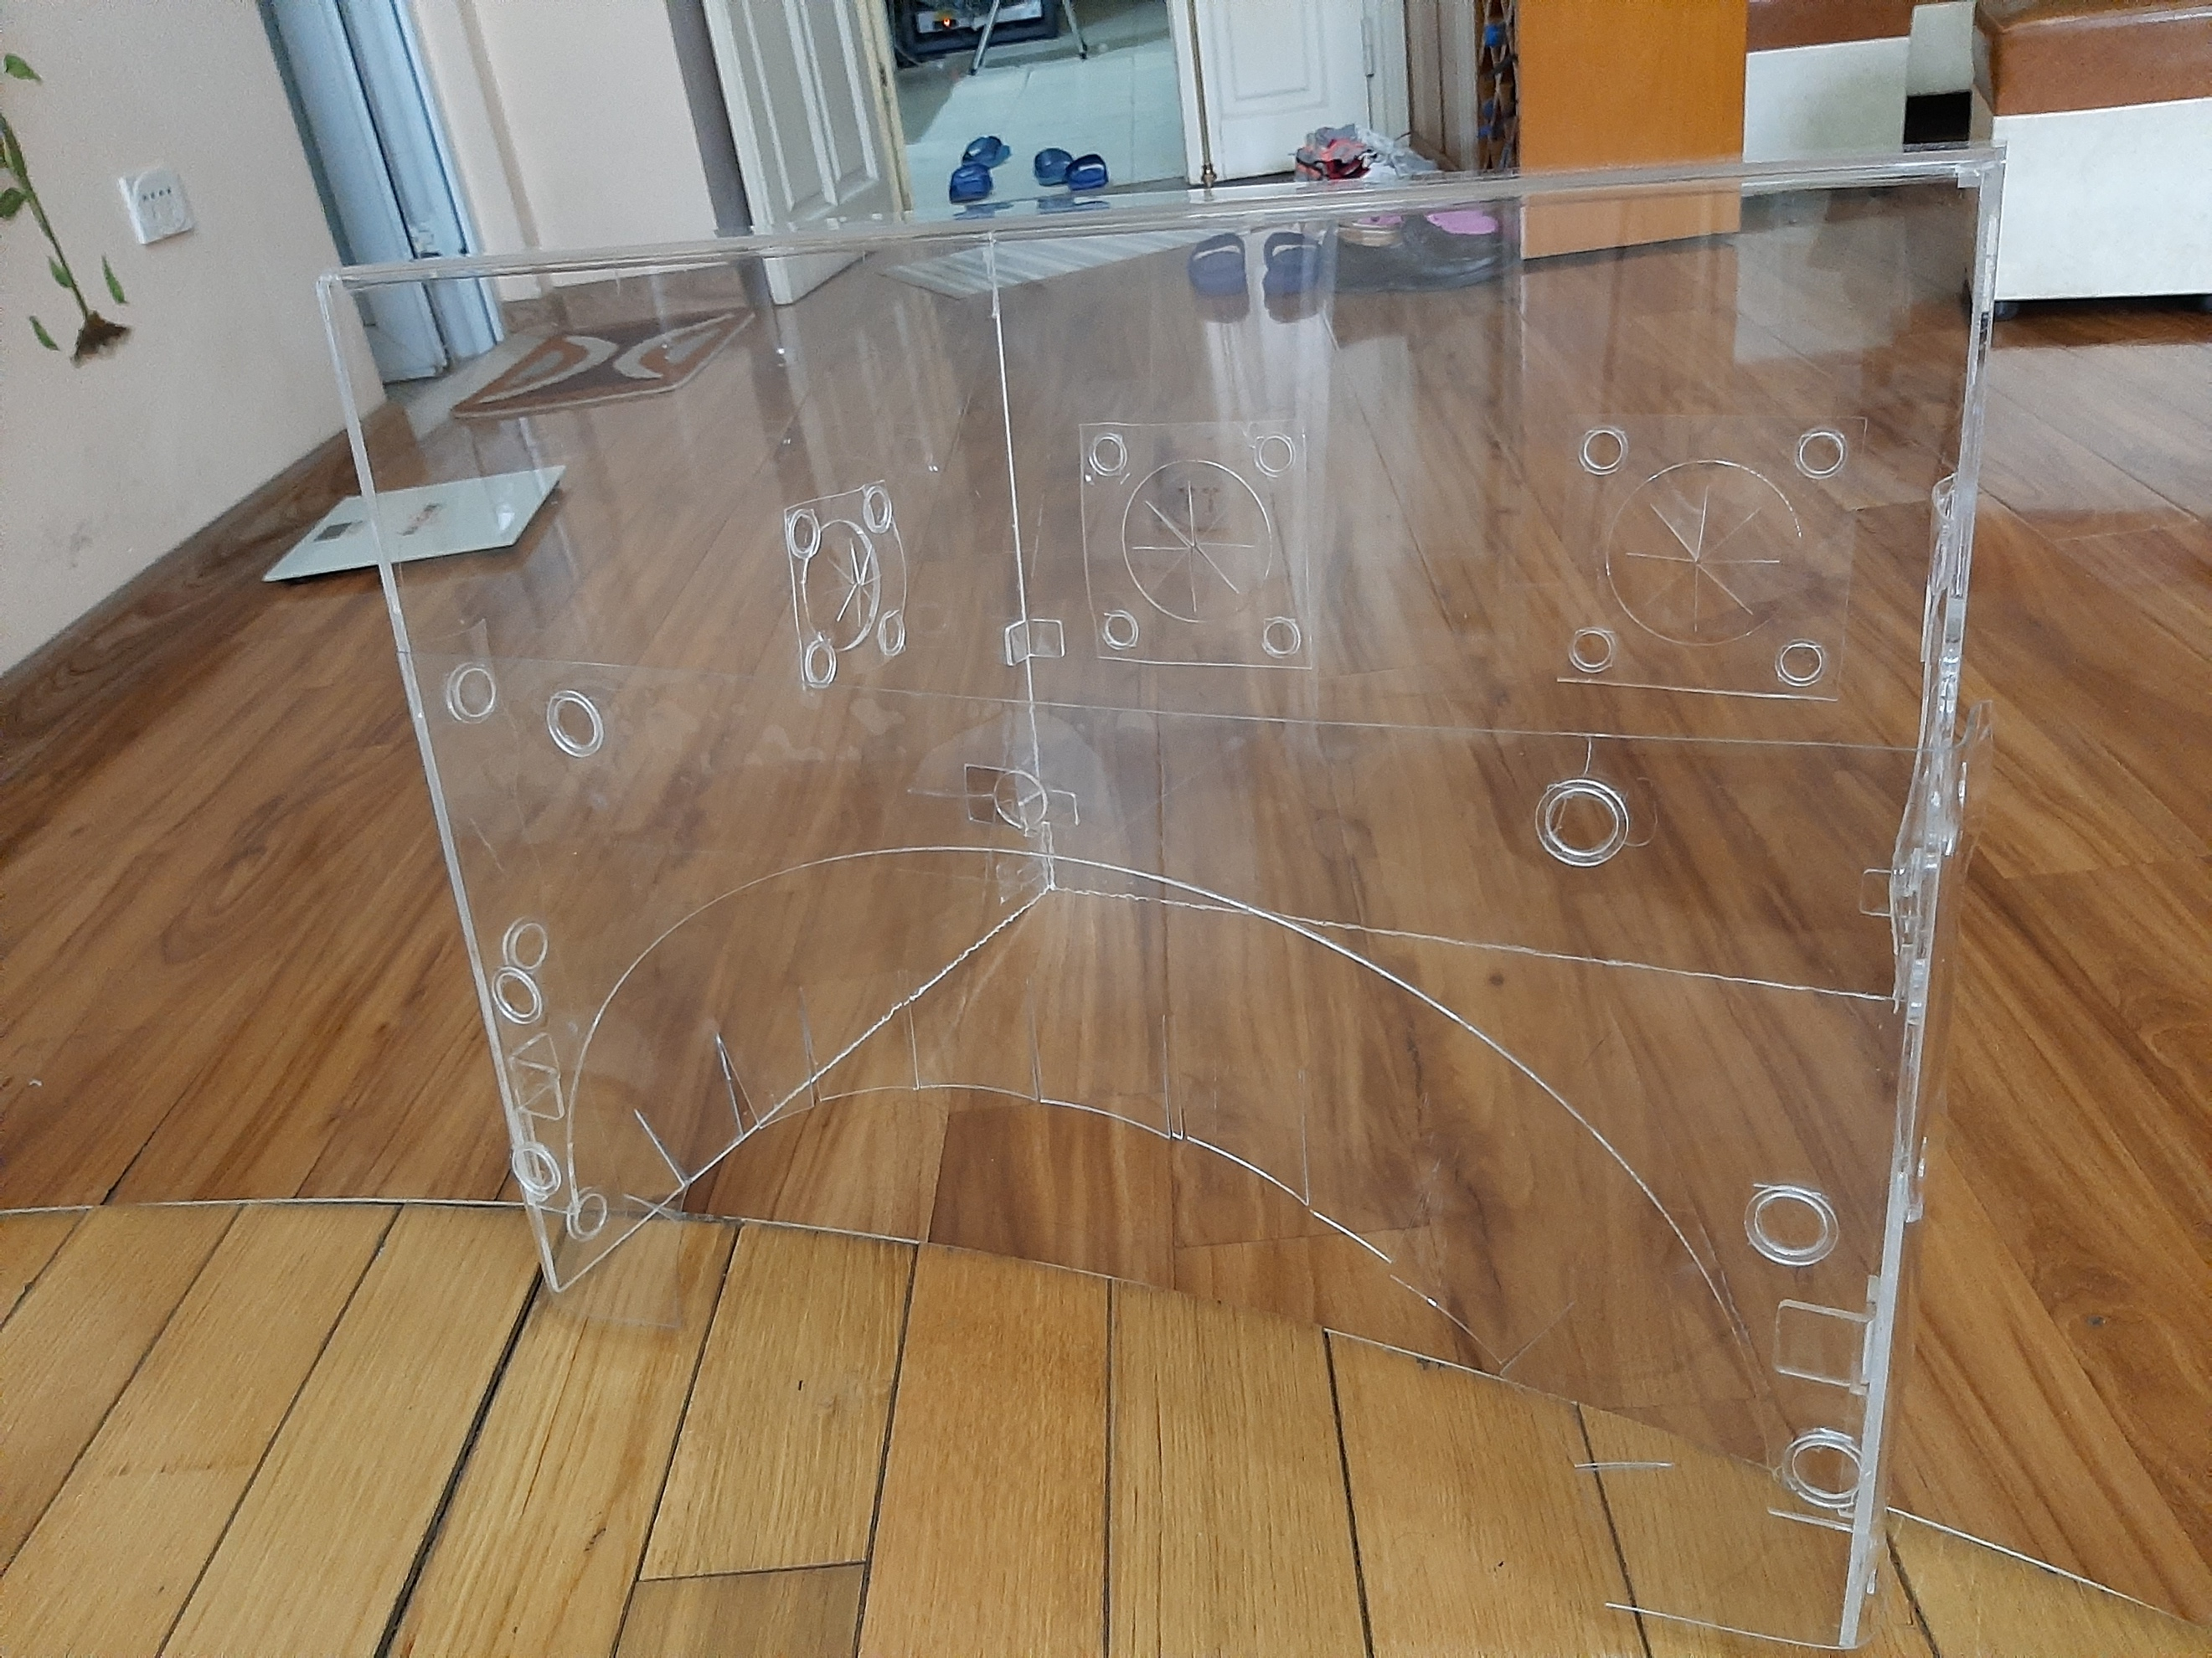  A real box photo: Leg-end of the box

